2020

Submission on capping international student numbers – July 2024

Senate Education and Employment Legislation Committee inquiry into the Education Services for Overseas Students Amendment (Quality and Integrity) Bill 2024

Andrew Norton
Professor in the Practice of Higher Education Policy POLIS: The Centre for Social Policy Research
The Australian National University
This is a personal submission that should not be taken to represent the views of POLIS or the Australian National University.

Table of Contents
List of figures 3
Overview 4
1. Introduction 5
2. Capping international student places by course 5
What is a course? 5
Data issues 5
Australia’s labour market or international student home country labour markets? 6
Migration patterns 7
Chances of permanent residence grants increasing 8
Courses with placement constraints 9
3. Trying to put international students in locations that don’t suit them 11
Regional universities offer lower fees 11
Studying outside of Melbourne Sydney & Brisbane has migration advantages 11
Regional universities have lost enrolment share 12
Reasons why international students prefer major cities 13
Policy coherence 13
4. Stranded places by university and course 15
5. The effects of harsh penalties for breaching an enrolment cap 17
Consequences of exceeding the cap 17
Hitting a precise enrolment target is not easy 17
Getting the enrolment ban lifted 18
Alternative enforcement 18
6. Conclusion 19
References 21

List of figures
Figure 1: Proportion of international students with permanent residence, by year of commencement 8
Figure 2: Permanent residence grants where the previous visa was a student visa or temporary graduate visa 9
Figure 3: Higher education enrolments by level of campus location migration advantage 12
Figure 4: Regional university international student market share 13
Figure 5: New international higher education commencements by time of year 17

Overview

- The government has already introduced multiple demand side measure to reduce international student numbers; it is not clear that supply-side constraints are also needed
- The government’s idea that international students should take courses relevant to Australia’s skills shortages does not reflect the reality that most international students return home
  - International students should be able to take courses reflecting their own interests and their home country labour markets
- The government should not necessarily encourage international students to take courses that are in domestic skills shortage and have finite clinical training and other placement capacity
  - This reduces opportunities for domestic students and creates the risk that international students will take their skills home with them
- The government wants to reduce international student numbers in major cities but capping places in metropolitan areas will not encourage many students to go to the regions
  - International students have good social, cultural and labour market reasons to prefer major cities
- Both course and institutional caps will cause ‘stranded places’ – university and other education provider places that are theoretically available but cannot in practice be used
  - As a consequence total enrolments will fall well below the caps
- The bill shows a lack of understanding of how difficult it is to hit precise enrolment targets
- The caps will encourage practices that are unethical and reputation damaging, such as withdrawing offers to international students or cancelling their enrolments

Introduction
This submission focuses on capping international student enrolments as proposed in the Education Services for Overseas Students Amendment (Quality and Integrity) Bill 2024. It does not consider the quality or integrity measures in that bill.

Capping international student places by course
The Education Services for Overseas Students Amendment (Quality and Integrity) Bill 2024 would give the minister power to cap international student numbers by course.

What is a course?
In higher education the concept of a ‘course’ is, for regulatory and other purposes, not as self-evident as it seems. Many courses are variations on each other, including ‘brackets degrees’, e.g. Bachelor of Arts (Journalism) or Bachelor or Business (Accounting), and combined or double degrees, e.g. Arts/Law.
Should these be taken as individual courses, or should they be grouped together as clusters of closely related courses? Universities that use generic course names (e.g. Bachelor of Arts) and then allow students to choose between majors would find that their caps are much more flexible. But this may disadvantage students who would prefer a degree that is more specifically branded.
In the case of a combined course, should the same person be counted twice, once for each course, for the purposes of their different caps? For migration purposes, there is still only one person.
Courses with different names share subjects and teaching staff. This can occur for subjects taught across multiple courses, such as maths or biology, or when students are required or encouraged to take subjects outside their core discipline.
Due to these interactions, regulation of one course can have unintended consequences for other courses, potentially threatening their viability by undermining their joint production.

Data issues
Unlike in vocational education higher education does not have standardised courses. Universities and some other higher education providers are self-accrediting, creating and approving their own courses. Other providers have their course accredited by TEQSA. As a result higher education has thousands of courses, with many created and phased out each year.
Partly for these reasons, the Department of Education generally does not currently publish course-level enrolment data, other than coding courses at a high level of field of education aggregation. For example, arts, law, psychology and social work courses are all aggregated into ‘society and culture’. Of the 388 occupations classified by the ABS as high-skill and typically requiring a degree, only seven have currently reported enrolments by relevant course.
Regulating at the course level is an enormous task which requires significant preparation work. The planned Australian Tertiary Education Commission is expected to do work that would support this regulation, but it will not start until 1 July 2025 and is unlikely to be fully operational until well after that.
As the Department of Home Affairs submission to this inquiry admits, its data systems and those the Department of Education are not currently in a position to administer this policy.
The Department of Home Affairs is, however, a model of good data practice compared to the Department of Education. Home Affairs regularly reports on international students as of a few weeks previously. The latest domestic higher education enrolment data from the Department of Education, by contrast, is for 2022.
Without recent domestic student data, Education will not understand the interdependencies between courses and between international and domestic students. The loss of international students may undermine the viability of courses taken by domestic students, forcing them to close.

Australia’s labour market or international student home country labour markets?
One rationale for the power to cap enrolments at the course level is the idea that international student course choices should reflect Australian labour market needs. For example, the government’s consultation paper tells us on page 18 that:
“While international students are an important source of potential skilled migration, student enrolments have not always been aligned with our national skills interests. In 2023, for example, 35 per cent of tertiary level international students studied business and management—skills not generally in shortage in Australia—and only 8.7 per cent studied in areas of health and education.”
Many international students have migration in mind. But in practice most international students leave Australia. They spend their careers in their home country’s labour market, or that of some other country. It makes little sense to restrict their options or steer international students to courses related to Australian skills shortages. International students should, and should be able to, take courses that reflect their own interests, and their own judgments of labour market prospects in countries other than Australia.

Migration patterns
The best analysis of international student migration patterns comes from the Grattan Institute, which used longitudinal migration data. For international student arrivals in the 2010s, typically a third to a half had no substantive visa after their student visa, with the figure varying by year and sector (vocational or higher education). They went home.
Other student visa holders went on to other visas, often a temporary visa, with some becoming permanent residents.
As Figure 1 shows, rates of transitioning to permanent residence have declined over time. For arrivals in the 2010s and later, less than 20% have achieved PR to date. This reflects tighter migration rules in the 2010s and the greater number of international students coming to Australia.
Figure 1: Proportion of international students with permanent residence, by year of commencement
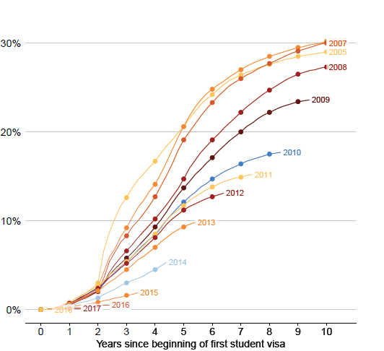
Source: Grattan Institute, Australia’s migration opportunity, p. 38.

Chances of permanent residence grants increasing
The government’s policies are – despite the language of ‘managed growth’ – likely to significantly decrease international enrolments. It is pulling every lever it can to constrain both demand and supply. All other things being equal, this will increase the chance the remaining students have of getting permanent residence, but not necessarily to a level that could justify restricting international students to courses chosen to reflect Australia’s skills needs.
If annual new international students arrivals were restricted to 150,000 per year – less than any non-COVID year since 2013 – that would still significantly exceed grants of permanent residence. While the published data does not provide a complete annual count of former student visa holders getting permanent residence, the traceable numbers are typically less than 50,000 per year, as seen in Figure 2 (2022-23 included clearing backlogged applications and is unlikely to be typical). We would be looking at the migration system being able to take about one in three international students. The rest would return home to work in their own countries.
Figure 2: Permanent residence grants where the previous visa was a student visa or temporary graduate visa
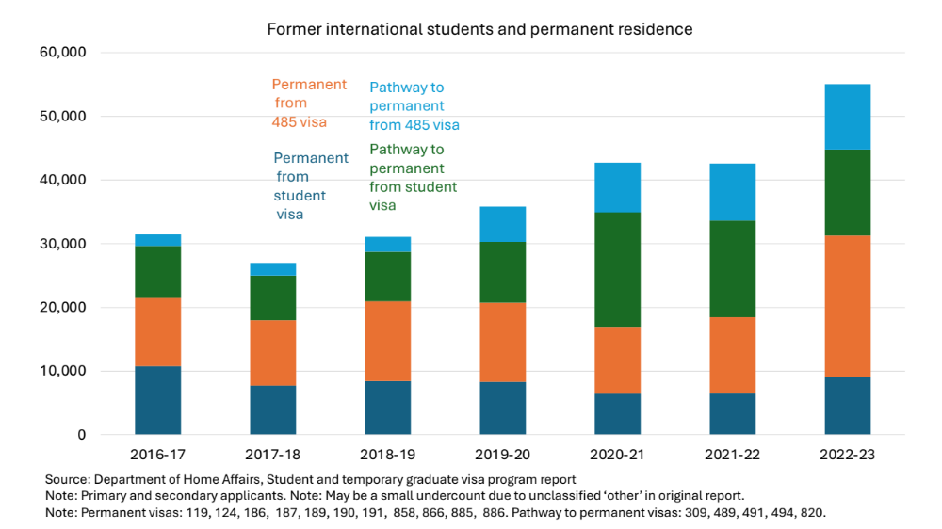

Courses with placement constraints
The health and education courses the government believes international students should be taking have practical constraints on total student places, due to the need for clinical training or other placements.
In these courses international students, due to the higher fees that they pay, could displace domestic students. The government’s policy of cutting international student numbers and revenue will force universities into measures they would not otherwise consider. The government should consider the potential consequences for domestic students, especially as courses like teaching and nursing have historically been popular with low SES students, who are a government higher education participation priority.
The government should also consider the skills supply consequences of increased international student enrolments in these courses, given that some international graduates will return home rather than work in Australia.
On a preliminary check the risks appear to be low for nursing. Nursing graduates have high rates of remaining in Australia, and international nursing graduates in Australia have high rates of working as nurses. However, these results and outcomes for other courses that might have no or high international enrolment caps need to be carefully analysed before proceeding with this policy. This analysis should also consider how changes in migration policy might affect the decision-making of future international students. For example, the source countries for nursing students may be particularly disadvantaged by increased financial barriers to studying in Australia.

.

Trying to put international students in locations that don’t suit them
The government intends to favour regional universities when setting caps. It acknowledges that less than 10% of international students currently live in regional areas.
The only new mechanism in this bill to encourage international students to study in regional areas is caps on students in major city areas. On the logic of this policy, prospective international students wanting to study in Australia will still do so, despite not being able to study in the university, or the city, that they have chosen. So far as I am aware, no market research supports this assumption.
The current low share of international student enrolments in the regions is despite existing incentives that favour regional universities.

Regional universities offer lower fees
On average regional universities offer lower fees than city-based universities – including at the city campuses regional universities established because they believe that most international students do not want to move to regional areas.

Studying outside of Melbourne Sydney & Brisbane has migration advantages
The government uses migration incentives to encourage regional enrolments. With 70% of international higher education students expressing interest in migration this should be a powerful lever.
Graduates of regional university campuses get 5 points towards a points-tested permanent residence visa, on top of the 5 points for any Australian degree.
Other regional migration benefits are divided into two categories.
The first category uses the term ‘regional’ loosely – it includes students enrolled on campuses in Perth, Adelaide and Canberra along with major regional cities. Graduates of these universities can get an additional year on their temporary graduate visa (so 3 rather than 2 years for bachelor degree graduates). For their nominated occupation to receive a permanent visa, graduates of campuses in these areas have access to the Regional Occupations List (ROL). This has 504 occupations, 77 more than the number on lists for other visa applicants. In Figure 3 these students are classified as ‘migration advantage’.
The second category of students, called ‘significant migration advantage’ in Figure 3, can get an additional two years on their temporary graduate visa (so 4 rather than 2 years for bachelor degree graduates). This second category has the same extended list of occupations for permanent residence, but their prospects of a visa are increased by access to dedicated regional places.
Despite these significant migration attractions, Figure 3 shows that most higher education international students – 74% as of late 2023 - choose locations with no regional-specific migration advantages – i.e. Sydney, Melbourne and Brisbane.
Figure 3: Higher education enrolments by level of campus location migration advantage
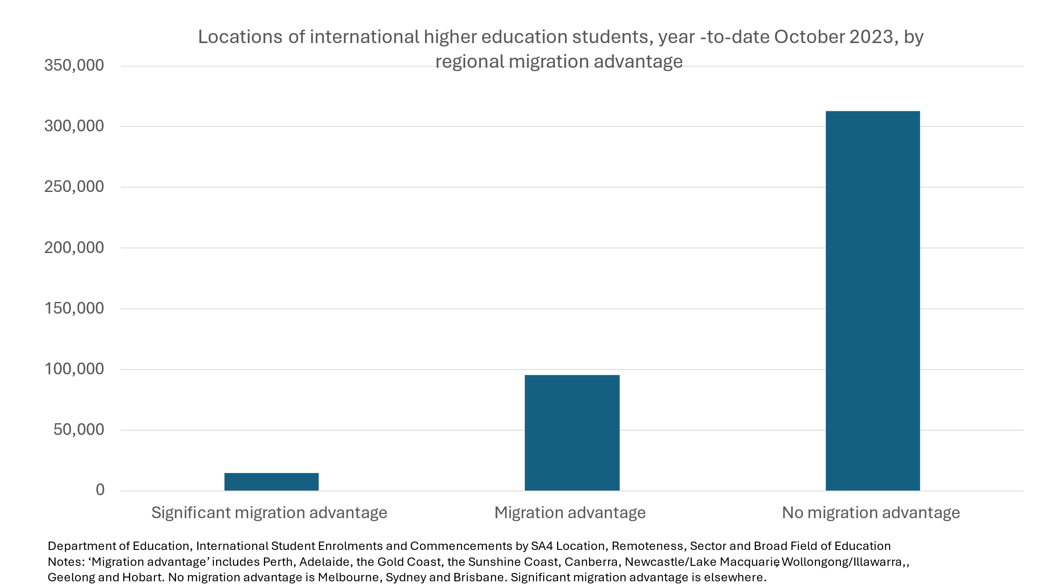

Regional universities have lost enrolment share
Regional universities – universities based in regional areas, although they may have campuses in major cities – generally increased their total international student enrolments up to the COVID-19 period. But metropolitan university international student enrolment grew more quickly. As a result, despite the cheaper fees of reginal universities and the migration benefits of regional locations, regional university market share declined, as seen in Figure 4.
Figure 4: Regional university international student market share
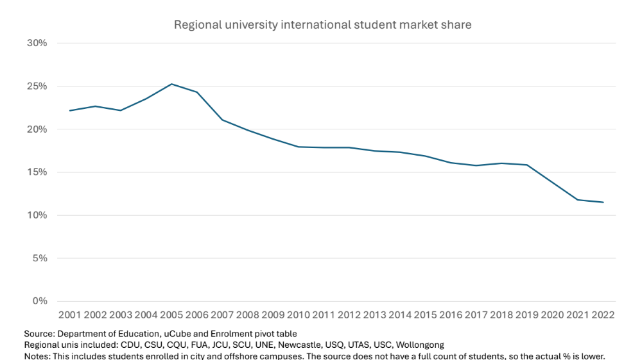

Reasons why international students prefer major cities
International students favour large cities for good reasons.
These cities narrow the social and cultural gap between Australia and student home countries, due to their significant temporary and permanent migrant populations from the major international student source countries. Areas around metropolitan universities often have shops and restaurants catering directly to international students.
Major cities have large and diverse labour markets for students seeking employment.
For international students focused on prestige considerations, all these universities are in major cities. They pay extra and forgo migration advantages for these benefits.

Policy coherence
The government’s overall migration strategy is undermining, and could further undermine, any benefits to regional universities coming from partially blocking metropolitan study pathways.
Ministerial direction no. 107, made in December 2023, effectively prioritised student visa processing for more prestigious universities. It has had, and is having, a significant negative effect on regional universities. Federation University, for example, has seen its new international student enrolments fall by 90%.
The migration policy paper released in December 2023 included the 5 points towards a points-tested visa for regional study in a list of ‘poor predictors’ of labour market success. This analysis was repeated in the April 2024 discussion paper on points-tested migration.
The international students who chose regional universities because of their low fees are likely to be most affected by increasing the visa application fee from $710 to $1600.

Stranded places by university and course
Sections 2 and 3 argue that assumptions behind the capping policy are mistaken and unrealistic. This section looks at how caps by institution and course would lead to lower enrolments than would be expected by adding up their totals.
All systems of prescriptively allocating student places run the risk of ‘stranded places’ – places that are theoretically available but cannot be in practice be used. This is because every condition added to the use of a student place reduces the number of potential students who could fill it.
The government has recent experience of this problem with domestic student places. In 2023 it allocated 10,000 of a promised 20,000 additional Commonwealth supported student places. These places had multiple criteria attached – they were allocated to specific higher education institutions, specific types of courses (those relating to skills shortage occupations) and specific types of students (members of equity groups). Universities were already facing soft domestic demand, maximising the need for flexibility to use their existing CSP funding rather than restricting it to specific courses and students.
Unsurprisingly, many of these prescriptively allocated student places will go unused. With another 10,000 places added in 2024, the government’s Universities Accord panel hopes to save the unspent funding for future use.
The government is repeating this mistake in international education.
Allocating more places to courses that international students don’t want to take will leave many of them unused rather than change course preferences.
Inability to fill course-level quotas will mean institution level caps won’t be met.
Allocating more places to regional universities will leave many of them unused rather than encourage a movement of international students to big cities.
These supply side policies will interact with multiple demand side changes to reduce international student enrolments:
- Higher visa application fees
- Increased financial requirements to support living in Australia
- Prohibitions on some onshore applications
- Less favourable temporary graduate visa lengths
- Unpredictable application of genuine temporary entrant and genuine student tests.
As these changes are likely to affect the less prestigious universities the most their caps will not be filled.
Elsewhere I have suggested a cap-and-trade system to support more efficient use of the available student places. However, as the current policy is already beyond the implementation capacity of the relevant departments it should not be considered at this point.

The effects of harsh penalties for breaching an enrolment cap
Under the Education Services for Overseas Students Amendment (Quality and Integrity) Bill 2024 the penalty for exceeding an enrolment cap is no further enrolments that year – in the institution or the course, depending on which cap was breached.

Consequences of exceeding the cap
This penalty is significant because an enrolment cap breach may only be temporary. Enrolments exceeding the cap in semester one does not necessarily mean breaching the cap through the year. Attrition and course completions will bring numbers down during the year. But unless special permission is secured, an education provider that exceeded its cap in semester one may be prohibited from enrolling any students in second semester.
As Figure 5 shows, mid-year commencements for new-to-Australia students are very significant. Pre-COVID they exceeded first semester commencements, in February or March at most universities. The timing of closing and then re-opening the borders made February/March commencements more numerous, but in 2022 and 2023 the two time periods had very similar numbers.
Figure 5: New international higher education commencements by time of year
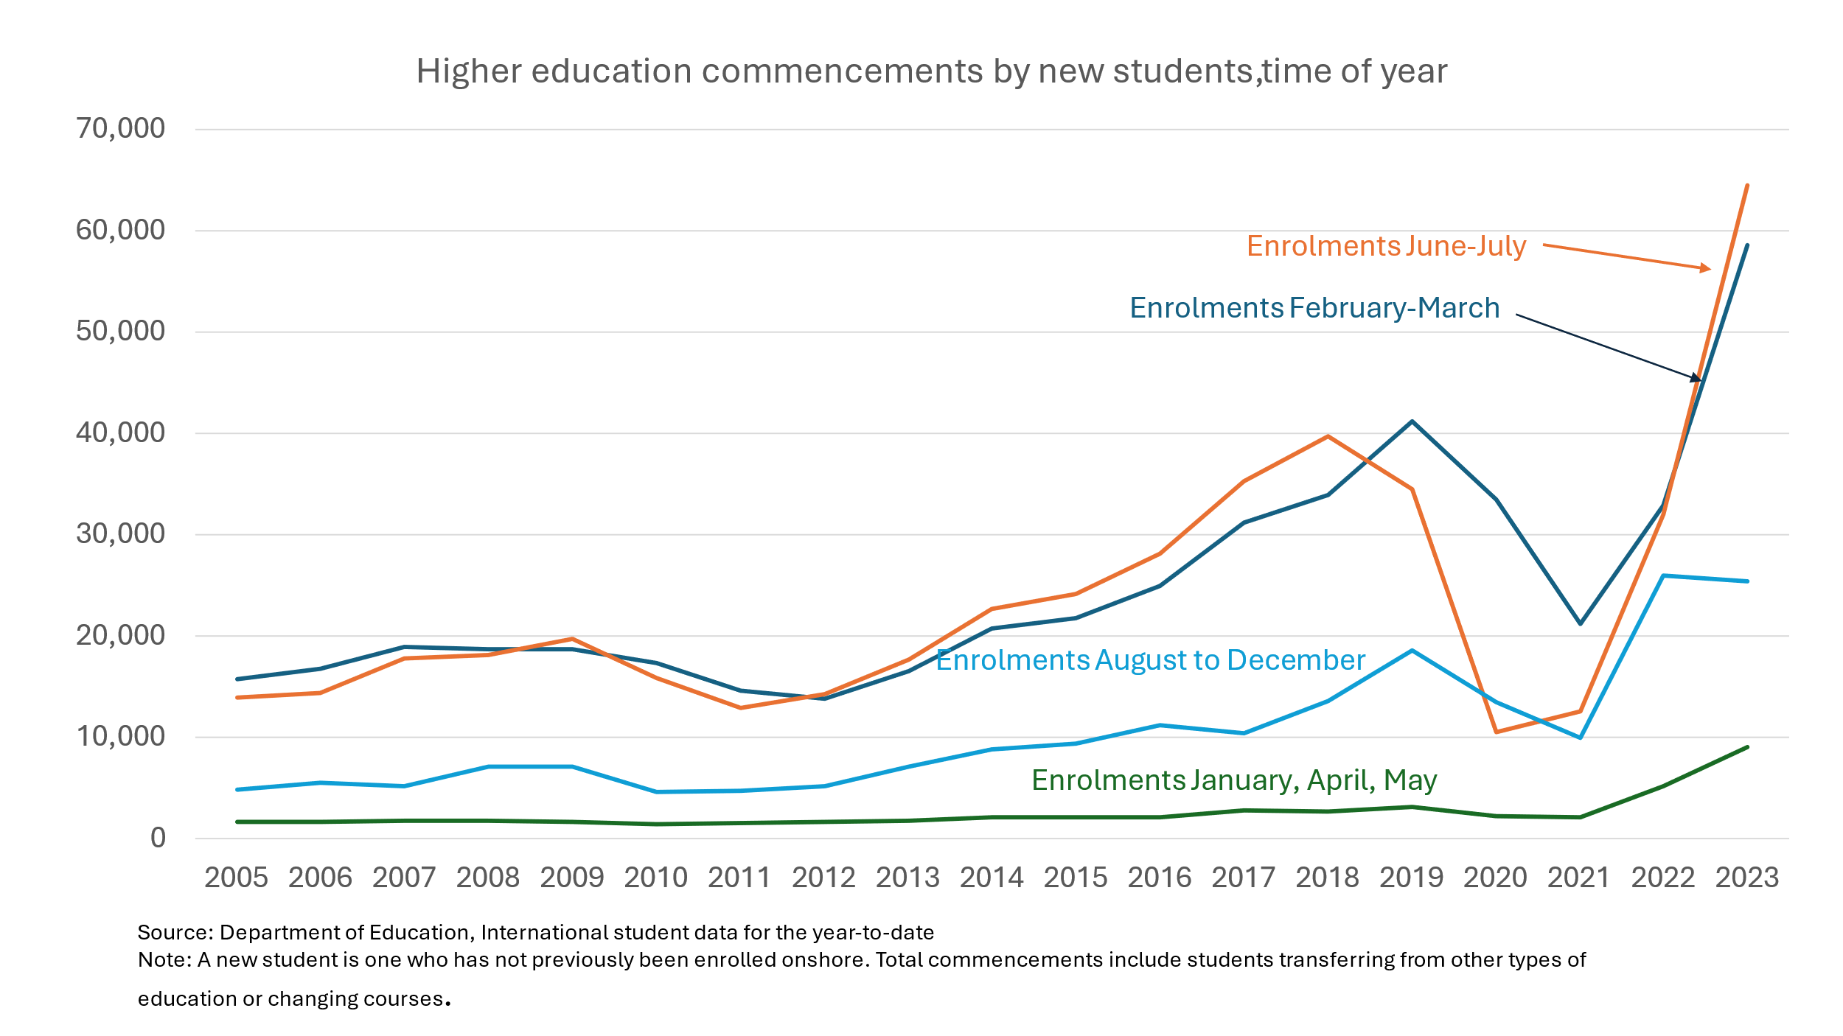

Hitting a precise enrolment target is not easy
As is the case for the government’s policy for distributing Commonwealth supported places, the student caps consultation paper and legislation appear oblivious to the practical difficulties in hitting precise enrolment targets. In the international student case, offer acceptance rates and attrition rates are key variables. Each rate can be estimated based on previous patterns, but universities can easily end up with a smaller or larger number of students than anticipated.
To avoid exceeding their cap(s) universities would need to change their enrolment practices. Confirmed offers may have to be replaced with conditional offers, that universities can withdraw if enrolments are getting too close to the relevant cap. The fact that the legislation gives the minister until 1 September (31 December for 2024) to make cap decisions means that key information will not be available prior to then. A conditional offer system would treat course applicants poorly.
In some cases, as the bill envisages in plans for compensating universities, actual enrolments may have to be cancelled. This would be exceptionally bad market practice.
These practices would damage the reputation of universities and Australia more generally.
For international student applicants the new system would encourage them to apply and accept early to reserve a place. This may have biases that are not immediately evident, such as benefiting applicants that get necessary school or other academic results at earlier dates. It may also create additional uncertainties for universities, if more applicants accept offers while still holding out for a better offer later.

Getting the enrolment ban lifted
The legislation includes a process for getting a suspension lifted, but it is a slow set of appeals and does not give clear grounds for why it should occur, such as that the provider is now below the relevant cap.

Alternative enforcement
Other enforcement provisions could be considered.
These could include a margin of error, expressed in an absolute number of enrolments or a percentage of the cap. Only above this would an enrolment ban apply.
The penalty could be fine rather than an enrolment ban. This would reduce the need to cancel offers or enrolments, which have as noted have high reputational risks.

Conclusion
Given the range of other measures already introduced to reduce the number of international students the caps proposed by the Education Services for Overseas Students Amendment (Quality and Integrity) Bill 2024 are unnecessary. Student numbers will fall significantly without it.
The capping system’s design would result in actual international enrolments well below the cap. This in turn would lead to larger job losses in the education sector than will otherwise be the case, more flow-on job losses and labour constraints in other industries than is necessary, and greater levels of international student disappointment and Australian reputational loss than needs to be suffered to reduce net overseas migration.
Aside from the significant negative consequences for universities and other education providers and for international students, this bill is an extreme example of the concerning decline of the rule of law in higher education policy. Rule-driven programs are being replaced with personal decision making by ministers.
For domestic students, I have highlighted how one-sided funding agreements with universities are being used implement policies that should have been put before the Parliament and to distribute student places in ways that are contrary to the intent of the funding legislation.
Irrespective of its substantive policy merits, ministerial direction no. 107 showed how high levels of personal ministerial discretion create unpredictability for students and providers.
Unannounced changes to the way visa applications were assessed cost visa applicants the fee they paid (then $710, now $1,600) and forced universities to cancel confirmations of enrolment.
Whether or not ministers exercise these powers in capricious ways, the fact that they have them changes the whole system.
For fear of losing their funding, universities go along with unlegislated requirements.
Every institution finds it hard to plan, because the rules can be changed easily and with little notice.
Students also find it hard to plan, because the rules are not stable and changes in rules can cost them their application fee and hopes of studying in Australia.
Education providers and prospective international students may dislike the visa rules. But if these rules are clear and stable both parties can make decisions with confidence. This cannot be the case with the proposed capped system, under which the minister can make decisions with a few months notice and for almost any reason.

References
ABS. Australian Census and Migrants, 2021 TableBuilder (Australian Bureau of Statistics, 2023).
———. Australian Census and Temporary Entrants 2021 TableBuilder (Australian Bureau of Statistics, 2023).
———. Education and Work, TableBuilder (Australian Bureau of Statistics, 2024).
Australian Government. Migration strategy: Getting migation working for the nation (Department of Home Affairs 2023).
———. Australia's international education and skills strategic framework (Draft for consultation) (Department of Education, 2024).
———. Australian Tertiary Education Commission - implementation consultation paper (Department of Education, 2024).
———. Australian Universities Accord final report (Department of Education, 2024).
———. Department of Home Affairs submission on the Inquiry into the Education Services for Overseas Students (Quality and Integrity) Bill 2024, Senate Education and Employment Legislation Committee (Department of Home Affairs, 2024).
———. Review of the point test - discussion paper April 2024 (Department of Home Affairs, 2024).
Coates, B., T. Wiltshire, and N. Bradshaw. It all adds up: reforming points-tested visas (Grattan Institute, 2024).
Coates, B., T. Wiltshire, and T. Resenbach. Graduates in limbo: International student visa pathways after graduation (Grattan Institute, 2023).
DHA. Student visa and temporary graduate visa program report (Department of Home Affairs, 2024).
DofE. Undergraduate applications, offers and acceptances 2021 (Department of Education, 2021).
———. Award course completions pivot table 2022 (Department of Education, 2024).
———. International student data - for the year-to-date (Department of Education, 2024).
———. uCube - Higher education statistics (Department of Education, 2024).
Hare, J. ‘Mass lay-offs at regional uni as international enrolments slump 90pc’, Australian Financial Review, 26 April 2024.
Mulder, D. ‘More evidence of eCOE’s being withdrawn and confusion within the sector’, The Koala: International education news, 9 February 2024.
Norton, A. ‘University-Commonwealth funding agreements and the rule of law in higher education’, Andrew Norton: Higher education commentary from Carlton (blog), 17 March 2021.
———. ‘The 20,000 equity places that nearly weren’t allocated and that will probably never be delivered’, Andrew Norton: Higher education commentary from Carlton (blog), 6 February 2023.
———. Mapping Australian higher education 2023 (ANU Centre for Social Research and Methods, 2023).
———. ‘Accord implementation proposals, part #3: The distribution of student places to universities and the folly of hard caps’, Andrew Norton: Higher education commentary from Carlton (blog), 25 June 2024.
———. ‘A cap-and-trade system for international student places ’, Andrew Norton: Higher education commentary from Carlton (blog), 27 May 2024.
———. ‘What's new in the university funding agreements, part 3: new rules on early offers’, Andrew Norton: Higher education commentary from Carlton (blog), 2024, 13 June.
Norton, A., and I. Cherastidtham. University fees: what students pay in deregulated markets (Grattan Institute, 2015).
SRC. 2022 Student Experience Survey: the international student experience (Social Research Centre/Department of Education, 2023).

A. Norton, Mapping Australian higher education 2023 (ANU Centre for Social Research and Methods, 2023), p. 129.
Australian Government, Australian Tertiary Education Commission - implementation consultation paper (Department of Education, 2024).
Australian Government, Department of Home Affairs submission on the Inquiry into the Education Services for Overseas Students (Quality and Integrity) Bill 2024, Senate Education and Employment Legislation Committee (Department of Home Affairs, 2024), p. 5.
Australian Government, Australia's international education and skills strategic framework (Draft for consultation) (Department of Education, 2024), pp. 3, 5-8, 10, 12, 15-18, 22, 27, 37.
70% in 2022: SRC, 2022 Student Experience Survey: the international student experience (Social Research Centre/Department of Education, 2023), p. 32.
B. Coates, T. Wiltshire and T. Resenbach, Graduates in limbo: International student visa pathways after graduation (Grattan Institute, 2023), p. 16.
DofE, International student data - for the year-to-date (Department of Education, 2024).
This count only includes people who moved directly from a student visa or a temporary graduate visa to PR. Former students or temporary graduate visa holders can move to another temporary visa and then to PR. As a rough guide to how many might be missing, 21% of people who arrived on a student visa between 2000 and 2017 and had PR by 2021 held 3 or more temporary visa sub-classes between arrival and PR: Calculated from: DHA, Student visa and temporary graduate visa program report (Department of Home Affairs, 2024).
As an example of the Department of Education data problems discussed above, the latest university applications data is for 2021. In that year low SES applicants were 23% of all health applicants, 24.5% of all teaching applicants, and 18.5% of applicants for other courses. Calculated from DofE, Undergraduate applications, offers and acceptances 2021 (Department of Education, 2021).
Based on analysis comparing international nursing completions (DofE, uCube - Higher education statistics (Department of Education, 2024); DofE, Award course completions pivot table 2022 (Department of Education, 2024) with Census linked data on former international students (ABS, Australian Census and Migrants, 2021 TableBuilder (Australian Bureau of Statistics, 2023); ABS, Australian Census and Temporary Entrants 2021 TableBuilder (Australian Bureau of Statistics, 2023).
Australian Government, Australia's international education and skills strategic framework (Draft for consultation), pp. 16, 21.
For example in NSW a city university non-Group of Eight business degree at Macquarie University costs $43,200 a year and at UTS it costs $44,920. At the University of Newcastle the fee is $35,655 and at Wollongong it costs $32,488. At the University of New England it costs $30,200. For an old but more detailed analysis of these patterns see A. Norton and I. Cherastidtham, University fees: what students pay in deregulated markets (Grattan Institute, 2015).
SRC, 2022 Student Experience Survey: the international student experience, p. 32.
B. Coates, T. Wiltshire and N. Bradshaw, It all adds up: reforming points-tested visas (Grattan Institute, 2024), p. 17.
See the Department of Home Affairs website, Designated regional areas page: https://immi.homeaffairs.gov.au/visas/working-in-australia/regional-migration/eligible-regional-areas
As of the 2021 Census international student employment rates were higher in regional areas (69%) than major cities (60%). However the absolute numbers of employed students were 17,000 in the regions and 202,000 in major cities. The differences may also reflect country of origin differences, with Chinese students that favour major city universities being much less likely to work than students from India or Nepal. In the May 2023 ABS Education and Work survey, 81% of students from Southern and Central Asian countries reported working, compared to 24% of students from North-East Asia. Caclulated from ABS, Education and Work, TableBuilder (Australian Bureau of Statistics, 2024).
J. Hare, ‘Mass lay-offs at regional uni as international enrolments slump 90pc’, Australian Financial Review, 26 April 2024.
Australian Government, Migration strategy: Getting migation working for the nation (Department of Home Affairs 2023), p. 56; Australian Government, Review of the point test - discussion paper April 2024 (Department of Home Affairs, 2024), pp. 7-8.
A. Norton, ‘The 20,000 equity places that nearly weren’t allocated and that will probably never be delivered’, Andrew Norton: Higher education commentary from Carlton (blog), 6 February 2023.
Australian Government, Australian Universities Accord final report (Department of Education, 2024), p. 291.
A. Norton, ‘A cap-and-trade system for international student places ’, Andrew Norton: Higher education commentary from Carlton (blog), 27 May 2024.
A. Norton, ‘Accord implementation proposals, part #3: The distribution of student places to universities and the folly of hard caps’, Andrew Norton: Higher education commentary from Carlton (blog), 25 June 2024.
A. Norton, ‘What's new in the university funding agreements, part 3: new rules on early offers’, Andrew Norton: Higher education commentary from Carlton (blog) 2024, 13 June; A. Norton, ‘University-Commonwealth funding agreements and the rule of law in higher education’, Andrew Norton: Higher education commentary from Carlton (blog), 17 March 2021.
D. Mulder, ‘More evidence of eCOE’s being withdrawn and confusion within the sector’, The Koala: International education news, 9 February 2024.

