2020

Supplementary submission on capping international student numbers – September 2024

Senate Education and Employment Legislation Committee inquiry into the Education Services for Overseas Students Amendment (Quality and Integrity) Bill 2024

Andrew Norton
Professor in the Practice of Higher Education Policy POLIS: The Centre for Social Policy Research
The Australian National University
This is a personal submission that should not be taken to represent the views of POLIS or the Australian National University.

Table of Contents
Overview 3
1. Introduction 4
2. Excessively broad ministerial discretion 4
3. Stating the enrolment limit 7
4. Penalties for exceeding the cap 9
5. Course caps 9
6. Amendments to give effect to government policy 10

Overview
- The Education Services for Overseas Students Amendment (Quality and Integrity) Bill 2024 gives the minister broad personal discretion in setting caps. This discretion goes well beyond what is required to control international student numbers.
- To limit the potential for misuse of discretionary power and to give Parliament greater scrutiny of policy, the bill should be amended to
  - Give it a clear migration purpose
  - Require the provider-level capping to be done by formulas or rules, so that the minister cannot favour or disfavour particular providers
  - The formulas or rules should be set out in a disallowable legislative instrument
  - The notices to specific providers should reflect the working out of the formulas or rules according to the relevant criteria
- The meaning of an ‘enrolment’ for the purpose of the caps needs to be set out in the bill
- Rather than capping based on a cumulative total through the year, caps at specific times during the year would better
  - Reflect the migration policy intent
  - Let commencement times align with academic years in source countries
- Given the inherent difficulties in managing enrolments to a cap automatic suspension & late cancellation of student enrolments are excessive penalties
  - Providers should instead be fined for breaching their caps
  - No international student who has enrolled in good faith should have their enrolment cancelled. This mistreatment would subvert the original intent of the ESOS legislation.
- The course caps have no reasonable policy rationale and should be deleted from the bill
- The government’s student exemptions – some government scholarship holders, students from certain locations, and students in twinning arrangements need to be authorised by an amendment to the bill

Introduction
This supplementary submission focuses on capping international student enrolments as proposed in the Education Services for Overseas Students Amendment (Quality and Integrity) Bill 2024.
I do not reject the idea of moderating international student numbers. My preference, however, would be wait to see what effect migration policy has before proceeding with caps. To July 2024, migration policy has had major effect on offshore vocational education demand. For higher education, July 2024 visa applications remain similar to pre-COVID levels, with losses from India being offset by strong Chinese numbers.
However with a Senate majority for provider-level caps this submission does not repeat earlier arguments in favour of no caps at all. It focuses on amendments that would make the bill less harmful to international students and the international education industry, while still allowing the government to achieve its migration policy objectives.

Excessively broad ministerial discretion
The Education Services for Overseas Students Amendment (Quality and Integrity) Bill 2024 would give the minister exceptionally broad discretionary powers. The implied threat that this allows – universities that displease the minister could be penalised with lower caps – changes the power dynamic between the minister and universities. This is not necessary to achieve the bill’s purposes. It is undesirable both as a general principle and in the context of Australia’s history of university autonomy.
Despite the broad discretion in the bill, the minister’s power will be somewhat constrained by the Administrative Decisions (Judicial Review) Act 1977. Appeals to the Federal Court could include claims that the minister’s decision involved errors of law, failures to observe the correct processes, no evidence to justify the decision, and improper exercise of power. The latter can include exercising a power for a purpose other than for which it was conferred, exercising discretionary power without regard to the merits of a particular case, exercising power in a way that is so unreasonable that no reasonable person could have so exercised it, and abuse of power.
Put a clear purpose in the bill
To guide what would count as a proper use of power the bill should have a clear statement of purpose – that the power is to be exercised as part of the government’s overall migration policy. This would appear at sections 26B and 26E, although in section 5 below I will call for 26E (the course cap power) to be removed from the bill.
Base the capping power on formulas and rules
To limit the minister’s ability to single out providers for specific unfavourable (or indeed favourable) treatment, section 26B should be redrafted to require use of formulas and rules in the legislative instrument. Based on the documents provided to the Senate inquiry, this is in fact how the government plans, in the first instance, to implement the capping policy. The parliament would have a chance to review these formulas and rules in the legislative instrument.
As now, the minister could differentiate between provider types and provider locations in drafting the formulas and rules. Named course categories could continue to be exempt from the caps.
Section 26C would then be redrafted. The redrafting would remove the power to cap providers independently of the Parliament, a process more open to abuse than the section 26B legislative instrument.
Section 26B(10) creates the power to vary the instrument without returning to Parliament. This is another unnecessary bypassing of the Parliament. Under section 33(3) of the Acts Interpretation Act 1901 the minister can use existing processes to amend the instrument if this necessary or desirable. Section 26B(10) should be removed.
As the legislative instrument would no longer contain a precise enrolment limit, the explanatory memorandum would need to include an estimate of how many enrolments would result from applying the formulas and rules.
Content of notices
The notice provisions would then show the results of applying the formulas and rules in the 26B legislative instrument to specific providers. This could involve the use of data that was not available at the time when the 26B legislative instrument was made, for example more up-to-date enrolment figures.
A new clause in section 26C should specify that the enrolment limit notices to each provider must be consistent with the legislative instrument made under section 26B.
As a further check on how the minister is exercising the capping power, a copy of the all the capping notices should by law be published on the website of the relevant Department.
Section 26C does not include an express power to vary notices – there is no parallel power to the section 26B(10) that I have recommended deleting. The Parliament should consider adding an express power to vary notices, for constrained reasons such as:
- A change in the legislative instrument
- A factual error, such as incorrect data being used in applying the formula or a mathematical or transcription error in creating the notice.
Where correction of the error involves a reduction in the provider’s cap this should be held not to apply to students who have already enrolled in the course and received a student visa. If the error was due to incorrect information supplied by the provider, a provider penalty could apply in such a case (section 4 below).
The reasons for varying a notice should not allow a reduction in the number of enrolments in the absence of a legislative instrument authorisation. The Department intends to redistribute places in April each year (Senate inquiry transcript for 6 September, p. 41). The precise context of this statement was for students who have enrolled but not turned up to commence their course. However due to second semester starts, discussed in the next section, most providers will have ‘unused’ places in April. Providers need to hold places in reserve for students starting later in the year.
Timing of the legislative instrument and notices
Under these proposed amendments, the legislative instrument must come before the notices.
As providers express concerns that the 1 September deadline is already late in the year the legislative instrument will need an earlier date, possibly 1 July. This would be after the government makes NOM-related decisions in the Budget, normally delivered in May.
A separate deadline would then be needed for the notices, although providers should be able to calculate or estimate them once the legislative instrument is available.
Delegation of power
If the power to set provider limits is constrained by formulas and rules, which are included in a disallowable legislative instrument, there is likely no need for the restrictions on delegation of powers in the Education Services for Overseas Students Amendment (Quality and Integrity) Bill section 170(1A)(b) and (c).

Stating the enrolment limit
Definition of enrolment
‘Enrolment’ is not defined in the ESOS legislation. This creates issues in stating and enforcing an enrolment cap. ‘Enrolment’ has at least two meanings within the amending legislation.
According to the Department’s Factsheet – Implementing provider limits in PRISMS the count of enrolments for capping purpose will occur a) when students are onshore and b) start their first non-exempt course.
However starting a course is several steps into the process of becoming an overseas student. A potential student must first enrol in the provider to receive a ‘confirmation of enrolment’, an essential step in getting a student visa. The cap cannot apply at this point, as ‘overseas student’ is defined in the ESOS legislation as ‘person (whether inside or outside Australia) who holds a student visa’.
Due to potential attrition at every step – not all people with a confirmation of enrolment get a student visa, not all people with a student visa turn up in Australia, student visa holders can arrive but never start their course – the basis of the cap count is critically important.
The Department’s definition is sensible but its statutory basis is not solid, as another definition of the count date – getting a student visa – is arguably more consistent with the ESOS Act as it stands. The Department’s definition should be clarified in the bill.
For provider management of the cap, however, a different definition of enrolment applies. Section 26D(1) reads, emphasis added:
‘A registered provider…must not enrol an overseas student [i.e. someone who already has a student visa], or intending overseas student…if the enrolment of that student would result in the provider exceeding [a relevant cap]’.
For all the attrition reasons mentioned previously, to use all or most of their cap a provider needs to enrol a greater number of prospective students than they believe will ever commence their studies. They also have a significant prior problem of the number of offers to make, knowing that not all people who receive an offer will enrol. The difficulty in knowing whether an enrolment would result in a provider exceeding its cap is relevant to enforcement, discussed in section 4.
Date of enrolment limit
The enrolment limit is expressed as a cumulative cap for the year, as opposed to a cap at any given date in the year. A cumulative cap seems unnecessary for migration purposes, as it includes people who have left Australia after completing courses or dropping out of courses.
The incentive a cumulative cap creates is for education providers to focus on starting students early in the year, so that revenue is received for the whole year. That could mean a larger semester one intake, and higher Australian population, than would otherwise be the case.
The demand-side constraint on first-semester course start dates is that these do not align with the academic years in source countries. With courses qualifying students for entry to Australian universities ending in the middle of the calendar year, a second semester start minimises the time between courses.
As Figure 1 shows, mid-year commencements for new-to-Australia students are very significant. Pre-COVID they exceeded first semester commencements, in February or March at most universities. The timing of closing and then re-opening the borders made February/March commencements more numerous, but in 2022 and 2023 the two time periods had very similar numbers.
Figure 1: New international higher education commencements by time of year
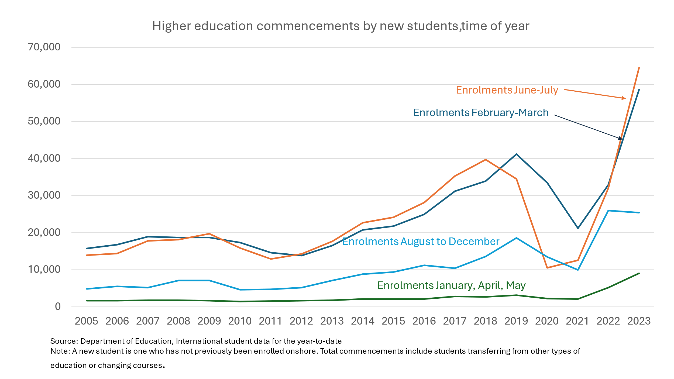
With more than one capping date during the year providers could re-use a place within their cap. For example, places vacated by students in semester one due to course completion or dropping out could be re-used for a second semester commencement.
The relevant dates would vary between institutions depending on their term or semester structures. These would have to be worked out in the notices to providers, with general guidance in the legislative instrument.

Penalties for exceeding the cap
The provider’s penalty for exceeding a cap is automatic suspension of enrolments for the rest of the year and not permitting accepted students to commence their course: section 96(2).
As it stands, automatic suspension is a disproportionate response to an enrolment process that is inherently hard to manage.
Cancelling an enrolment at this late stage would be grossly unfair to students, who may have spent significant amounts of money getting to Australia. At best, their study plans would be delayed. By the time enrolments are cancelled it could be too late to find an alternative. It would be a terrible irony if the ESOS Act ended up mandating the mistreatment of international students that it was originally enacted to prevent.
Alternative penalties to the current bill - fines
A system of fines would deter providers from behaviour that led them to recklessly exceed the cap while not forcing them to cancel enrolments at the last minute.
The fines could be related to the level of fees charged. The fines could escalate according to the number of enrolments above the provider’s cap.
Automatic lifting of suspension
While the suspension is automatic, lifting it after enrolments fall back below the cap – as is likely due to attrition and course completion – is not. The suspension is lifted on 31 December or if the Secretary of the Department decides to lift it.
By the time a decision to lift is made it may be too late for the provider to enrol students. The lifting of suspension should be automatic if enrolments fall back below the cap.

Course caps
The government has not made any convincing argument for course caps. The idea that international students, most of whom will leave Australia, should be restricted to courses matching Australia’s skills needs does not make sense.
The bill should retain the power (section 26B(4)) to exempt courses from the cap.
Subdivision C of the Education Services for Overseas Students Amendment (Quality and Integrity) Bill 2024 and section 96A, along with any other connected provisions to course cap should be deleted or amended as appropriate.

Amendments to give effect to government policy
Since the Education Services for Overseas Students Amendment (Quality and Integrity) Bill 2024 was introduced the government has announced policies that are not supported by the bill as it stands.
While there are clear provisions to exempt specified types of provider or course from the caps, this is not the case for specified types of students, such as students with Australian government or ‘key partner’ scholarships or students from the Pacific or Timor-Leste.
The exemption for students in ‘twinning’ arrangements – taking part of their course overseas, part in Australia – is less clear as to whether it is covered by the bill. While arguably this is a type of course it is not clear that this is a course as defined by section 5AA of the ESOS Act.
A provision to exempt specified types of stud

ents from caps should be included in the bill. This decision should be part of the legislative instrument put before the Parliament.

References

Norton, A. ‘Can migration policy alone manage international student numbers?’, Andrew Norton: Higher education commentary from Carlton (blog), 5 August 2024.
———. ‘Limits on international student numbers could reduce enrolments to well below the official cap’, Andrew Norton: Higher education commentary from Carlton (blog), 13 May 2024.
———. ‘Migration policy will keep vocational enrolments below the cap’, The Koala: International education news, 2 September 2024.

A. Norton, ‘Can migration policy alone manage international student numbers?’, Andrew Norton: Higher education commentary from Carlton (blog), 5 August 2024; A. Norton, ‘Migration policy will keep vocational enrolments below the cap’, The Koala: International education news, 2 September 2024.
A. Norton, ‘Limits on international student numbers could reduce enrolments to well below the official cap’, Andrew Norton: Higher education commentary from Carlton (blog), 13 May 2024.

